**Assignment 19.2**

**Problem Statement:**

Convert XML File into Json File Format. You can consider below example XML, save it in the hdfs cluster and then to convert into Json File Format. Share the codes used with the screenshot for the same.

You can refer our below link Blog:

<https://acadgild.com/blog/quick-way-convert-xml/>

**Input:**

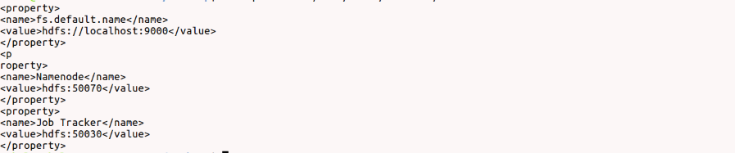

**Program:**

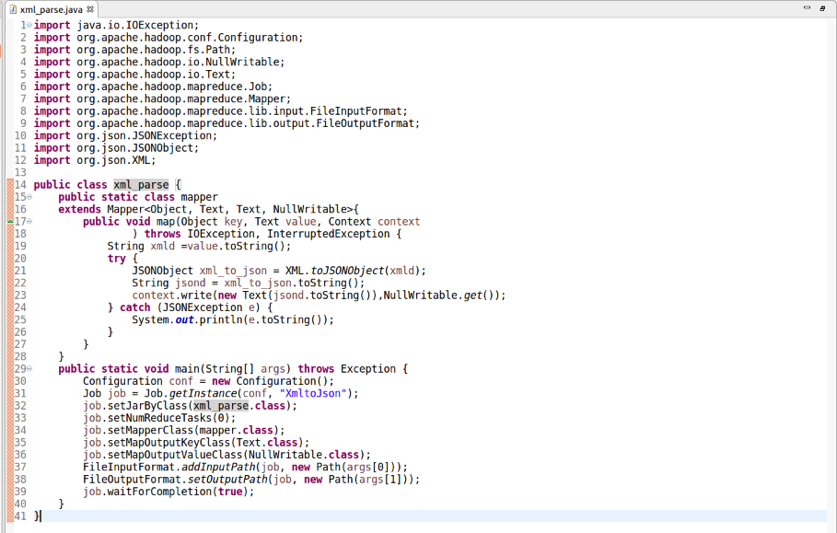

**Output:**

